CIDM 6355 Data Mining Methods HW1

**Requirements:** Follow the instruction, take the required screenshots with date and time (see the examples in RapidMiner Lab instruction), and answer all the questions. Sharing your queries, screenshots, or answers with other students is considered as cheating, which will be reported to the university authority. A screenshot without showing reliable date and time will receive a penalty of 50% of points. If identical screenshots are found from two or more students, such a misconduct will be reported to the university authority. Please type your name as below to indicate that you understand and comply with all the requirements in this homework.

**Part 1:** Answer all the questions in Week 4 RapidMiner Lab (Step 1.3, 1.8.1-1.8.5, and 2.2.3 – 2.2.4) and an additional question via HW1-Part 1 Submission (40 points). You have two attempts, and the higher one will be counted into your grade. Please DO NOT include them here; otherwise, they won’t be graded here.

**Part 2:** Lab Screenshots and Deliverables (60 points)  
Take the required screenshots with date and time and answer all the questions. Windows and MacBook show the date and time differently, so your screenshot is acceptable as long as it displays the date and date, no matter how. MacBook displays the date and time on the top right corner. If you do not know how to take a screenshot, please check this website <https://www.take-a-screenshot.org/> for more instructions. If you do not know how to show the date and time on your MAC Book, Google your question or try this site. Sharing your queries, screenshots, or answers with other students is considered as cheating, which will be reported to the university authority.  
 1) Screenshots in RapidMiner Lab (10 points)

• Screenshot 1: A screenshot of the decision tree graph with date and time at Step 1.8 (5 points)

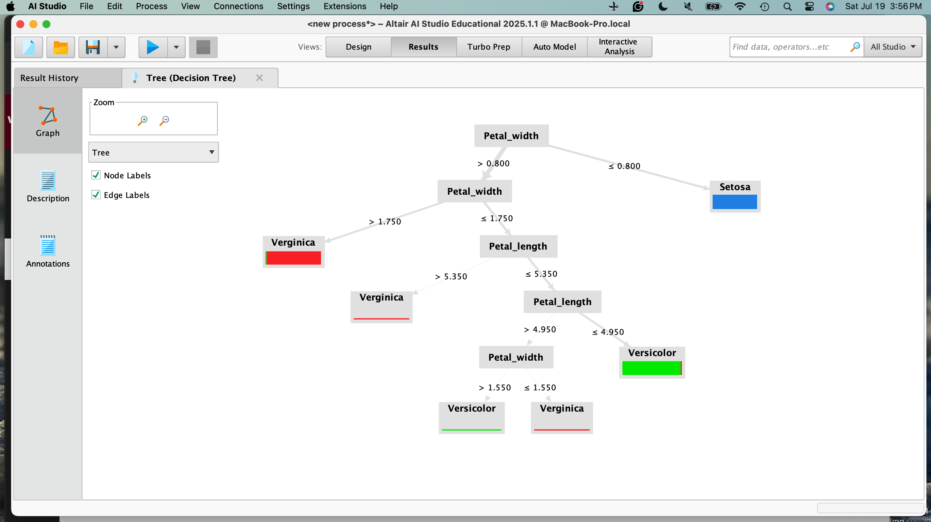

• Screenshot 2: A screenshot of prediction results for the 19 observations with date and time in Step 2.2 (5  
points)

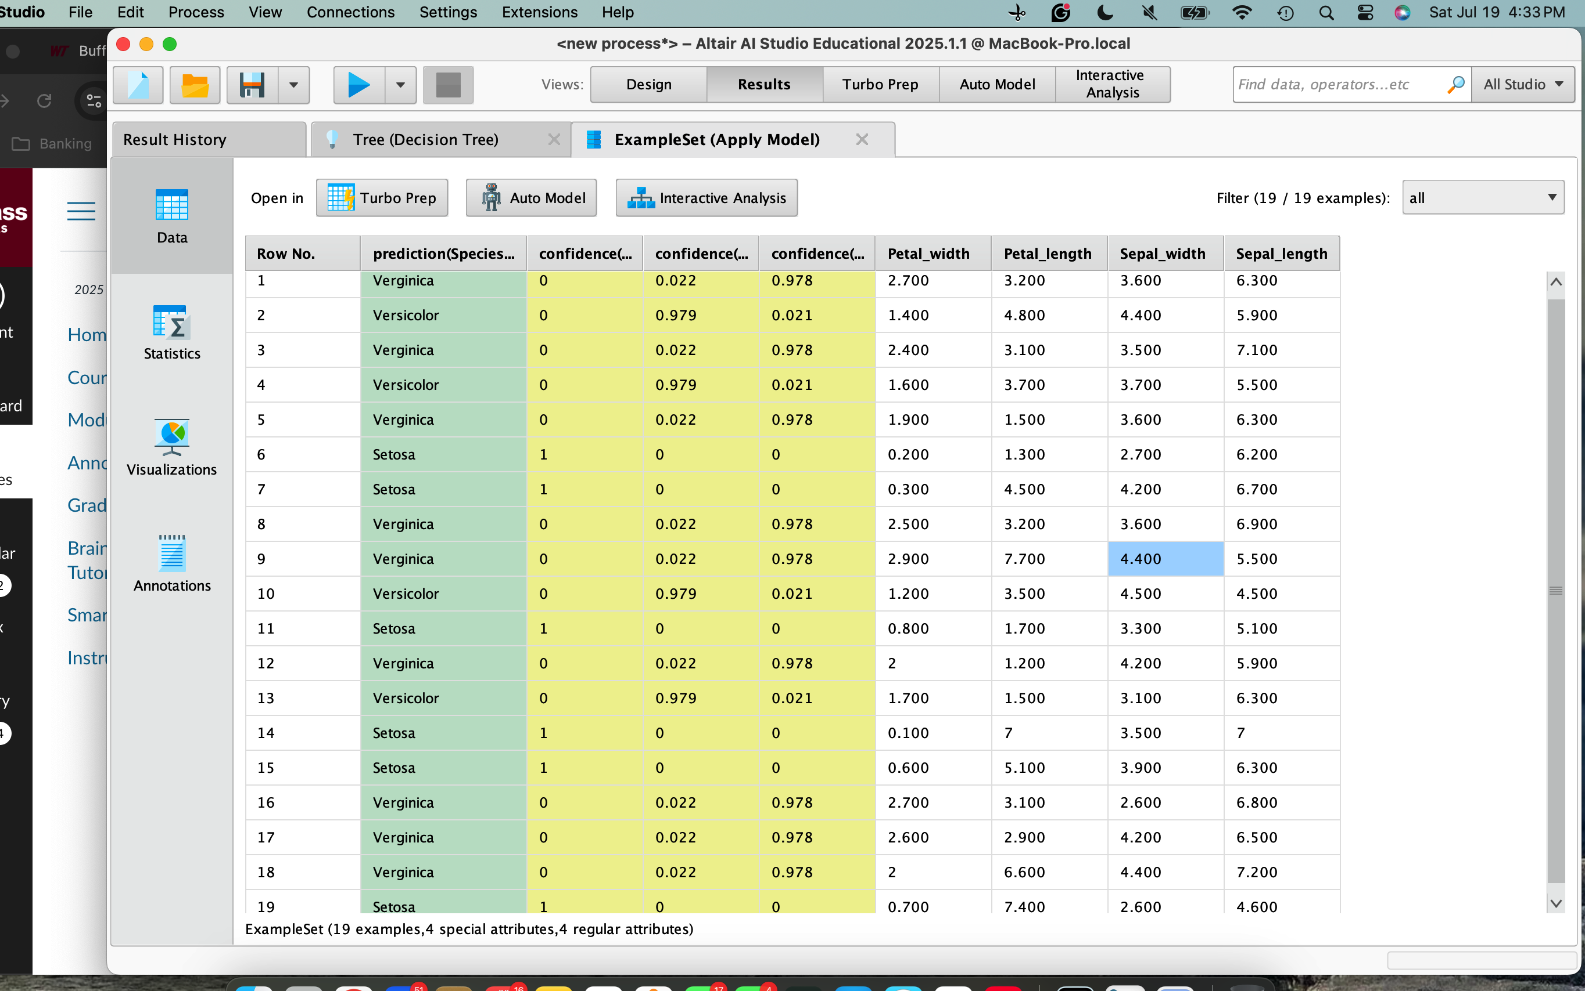

2) Deliverables in R Lab (50 points)

• **Deliverable R1:** take a screenshot of your decision tree model with date and time (5 points).

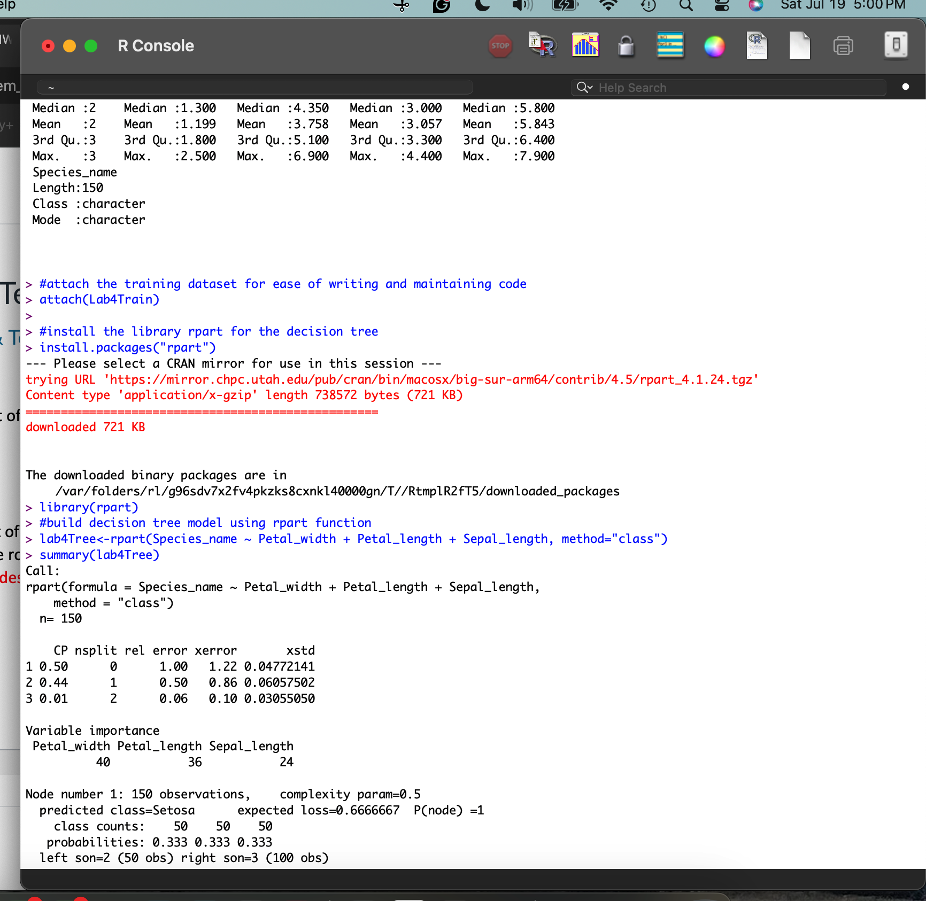

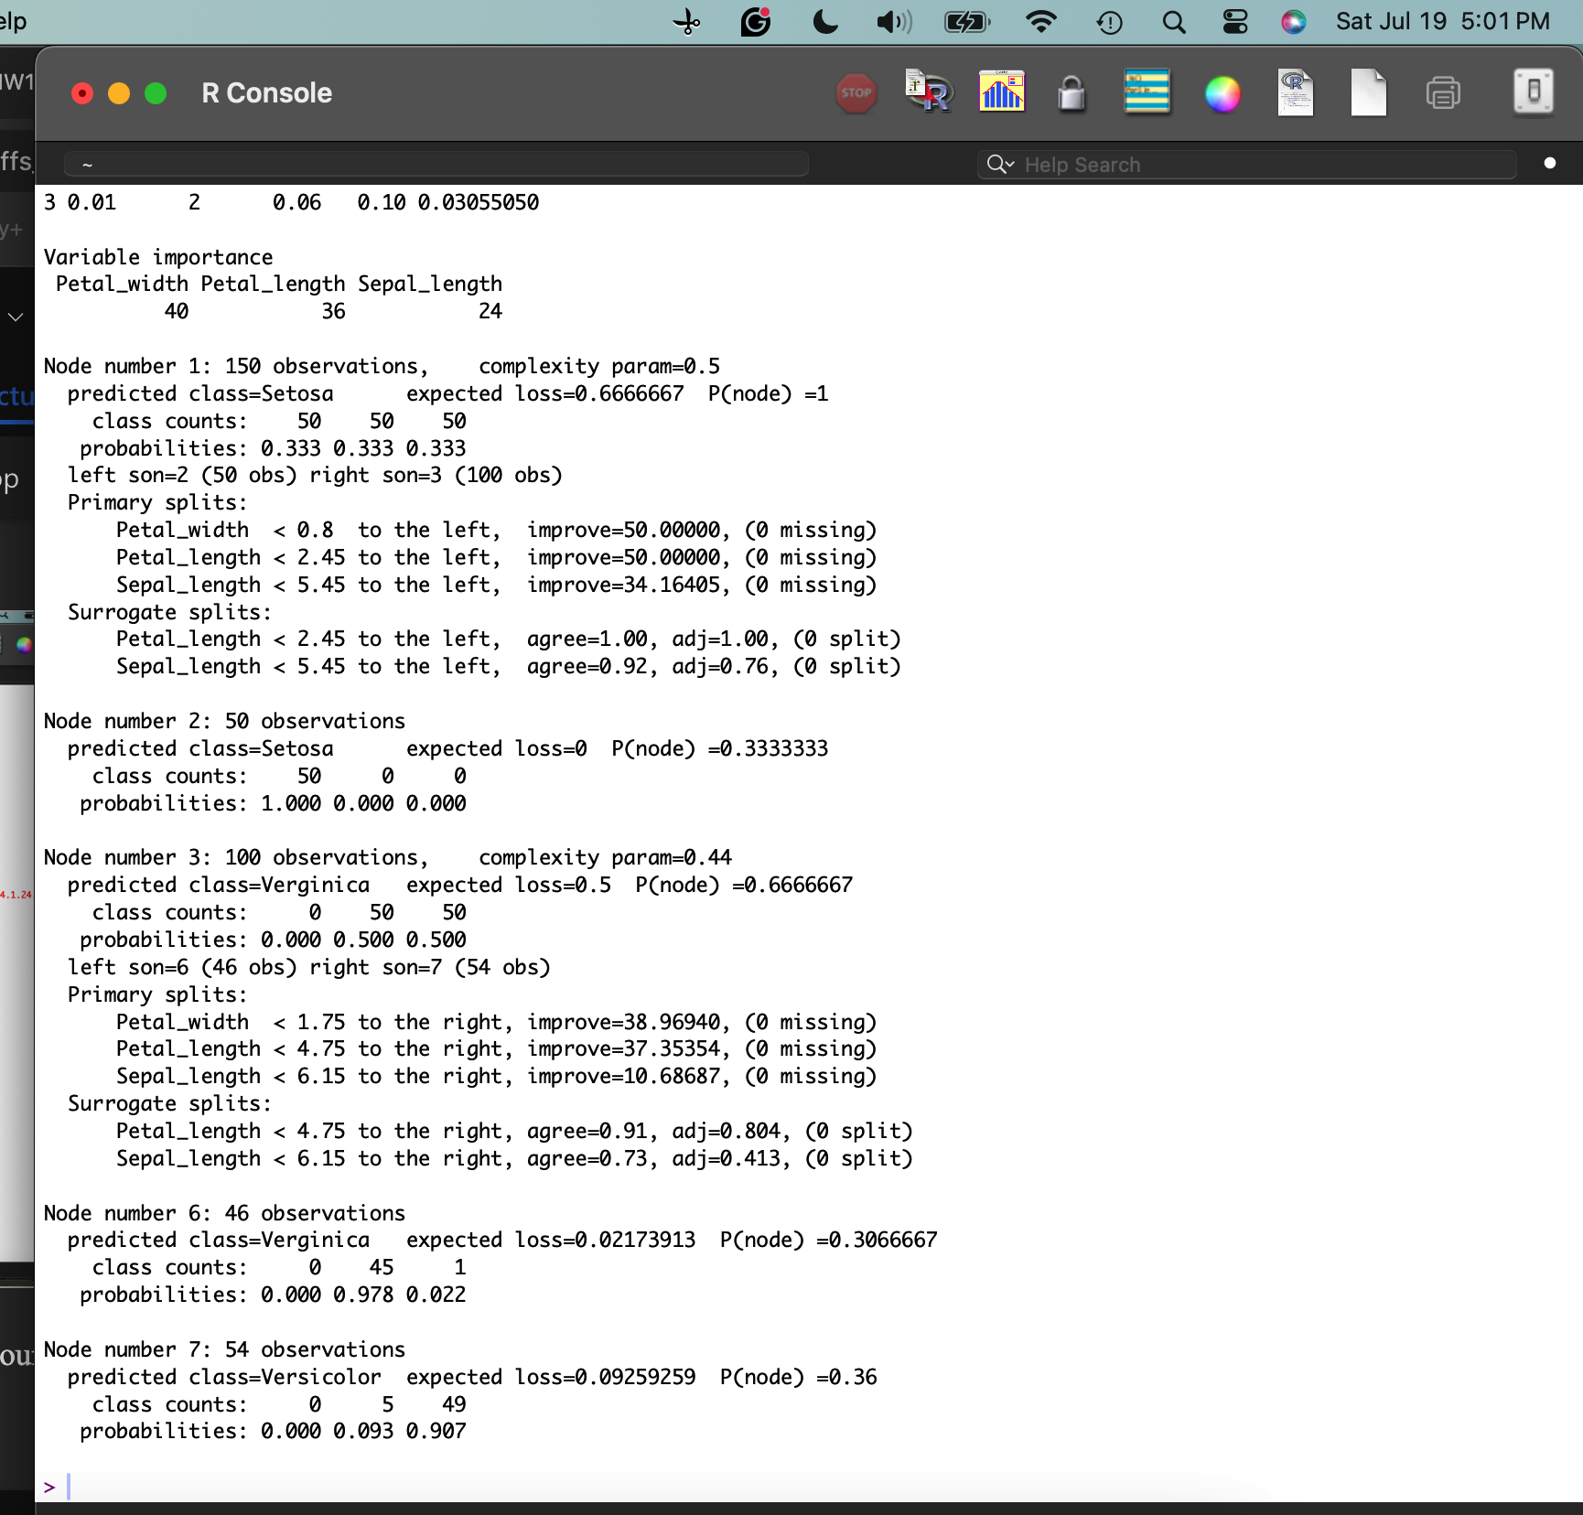

* **Deliverable R2:** take a screenshot of your decision tree graph with date and time and briefly describe it. Your description must include the root node, split nodes, and leaf nodes. (10 points: 5 points for your screenshot and 5 points for your description).

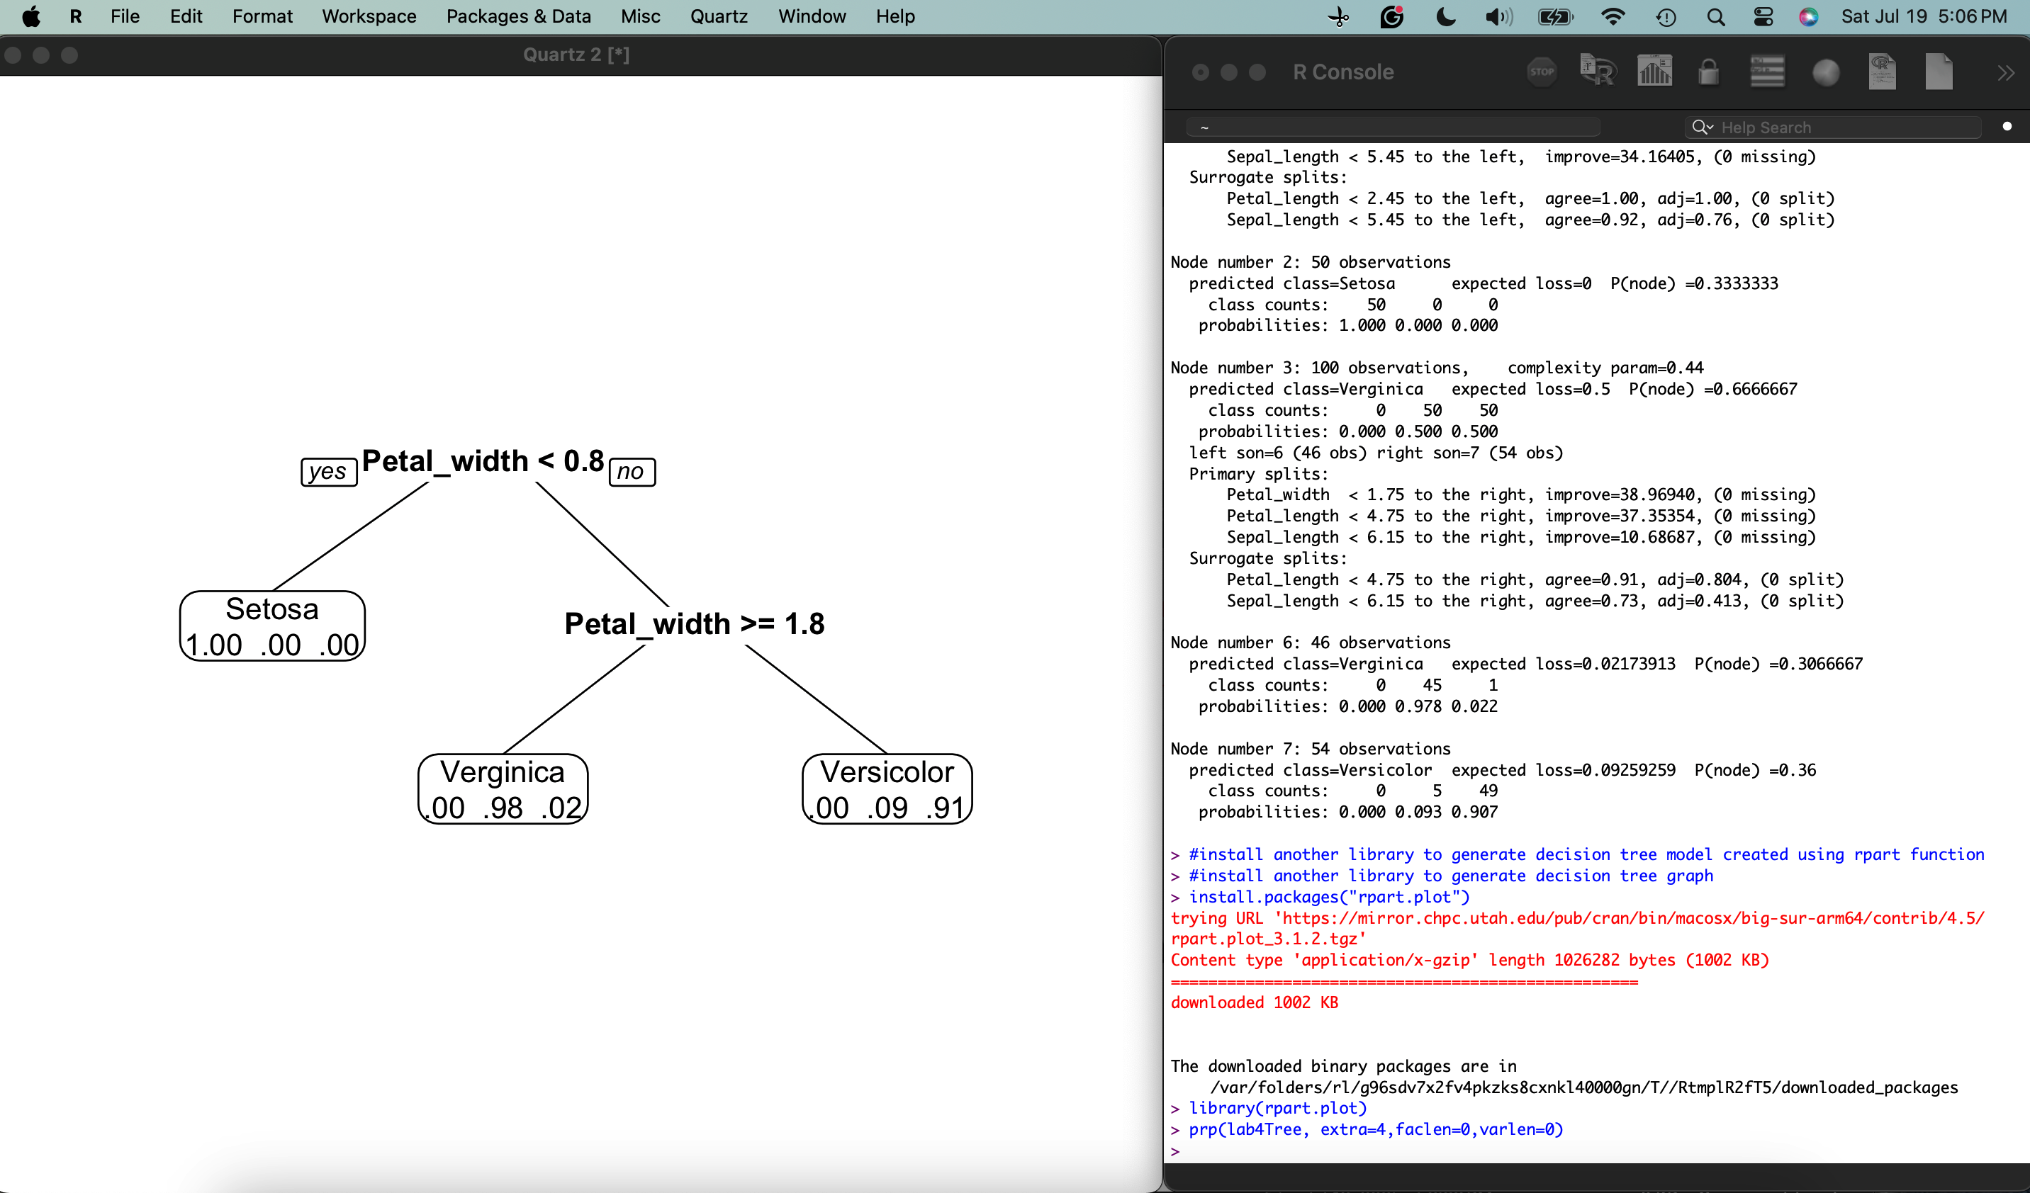

The decision tree graph that is generated is small. The root node indicates that the initial decision point for identifying the flower is based on its petal width. If the petal width is less than 0.8, then it is a Setosa (which is a leaf node), but if it is greater than 0.8 it there a second split node decision point. There is one split node, which indicates another divide by petal width. If the petal width is greater than or equal to 1.8, then it is a Verginica (which is a leaf node). If it is not, then it is a Versicolor (another leaf node).

* **Deliverable R3:** after you apply the decision tree model to your prediction dataset, take a screenshot of the prediction result with date and time and briefly describe how the result help you determine the predicted class of each case. (10 points: 5 points for your screenshot and 5 points for your description)

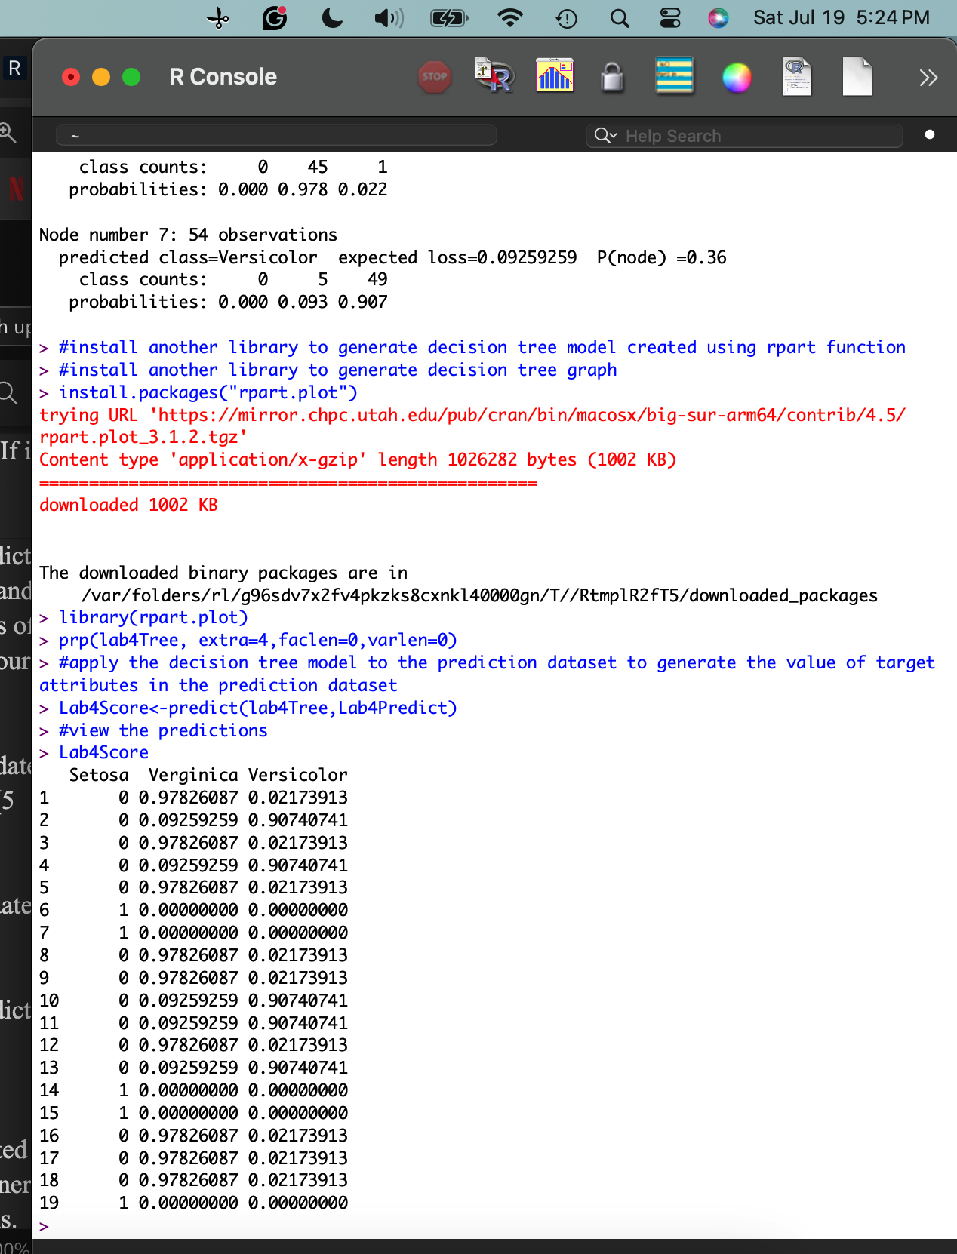

The results provided help to determine the predicted class of each case by providing the user with the probability of each case being a particular type of flower. To identify the predicted class of each case, see which class has the highest probability.

* **Deliverable R4:** take a screenshot of your decision tree model with date and time. Try to use the resources provided to understand its output (5 points).

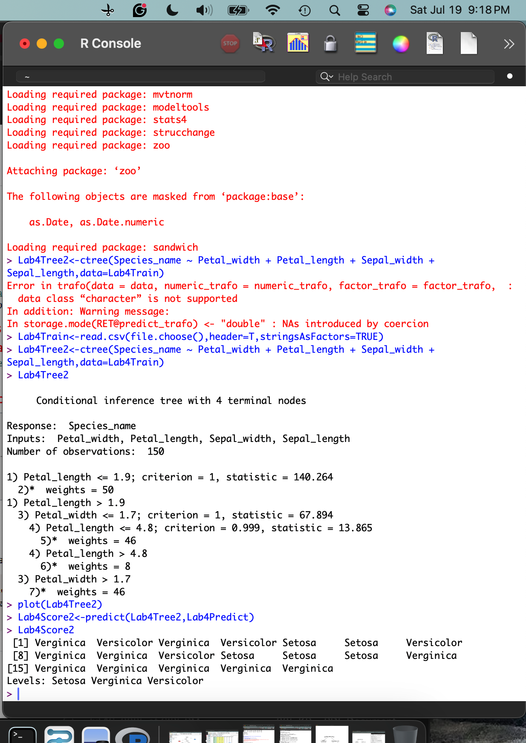

* **Deliverable R5:** take a screenshot of your decision tree graph with date and time (5 points).

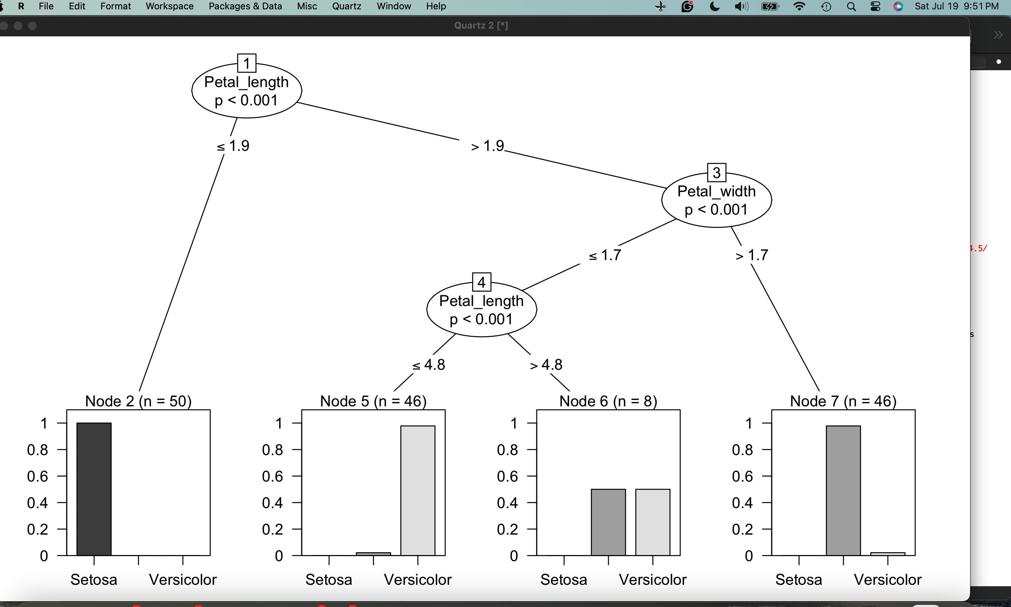

* **Deliverable R6:** after you apply the decision tree model to your prediction dataset and take a screenshot of the prediction result with date and time (5 points).



* **Deliverable R7:** Choose one of the two decision tree models generated in R and compare it with the decision tree model generated in RapidMiner. Identify and discuss at least three differences between the two models. When discussing each difference, please include both R and RM. For example, "R does ..., but RM does not ...." (10 points).

 R Studio

 Rapid Miner AI Studio

1. Rapid miner (RM) uses the petal width as the root node, whereas R studio (R) uses the petal length as the root node in the decision tree.
2. RM has a deeper and more complex decision tree, as can be seen as there are many more splits and a total of 4 internal nodes after the root node. R can only be seen as having 2 internal nodes after the root node. It is much shallower.
3. RM’s decision tree nodes display the split condition and the name of the deciding factor. R’s decision tree, however, is more insightful by providing class probabilities as well as the count of each leaf node.